**Output:**

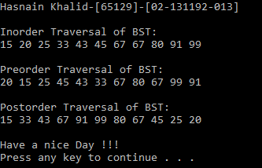

Bahria University,

Karachi Campus

LAB EXPERIMENT NO.

____**11**_____

LIST OF TASKS

|  |  |
| --- | --- |
| TASK NO | OBJECTIVE |
| 1 | Implement the AVL Tree by performing searching. |
|  |  |
|  |  |
|  |  |
|  |  |
|  |  |

Submitted On

04/01/2022

(Date: DD/MM/YY)